Instructor: Dr. Jie Shen
Release date: Feb. 09, 2021
Due date: Feb. 15, 2021

Student Name: Demetrius Johnson
*Special note: see my lab uploads of the .CPP and .EXE files for ease of access and testing any of the programs for any question.

Table of Contents
Question 1 3
Source code (USED C++ COMPILER) 3
Test data and expected results 5
Question 2 6
Source code (USED C++ COMPILER) 6
Test data and expected results 7
Source code (USED C++ COMPILER) 10
Test data and expected results 12
Question 4 16
Source code (USED C++ COMPILER) 16
Test data and expected results 18
Submission 19
Provide the following in an MS word document: 19

Question 1

Source code (USED C++ COMPILER)
// CIS-200-LAB 4 -DemetriusJohnson.cpp : This file contains the 'main' function. Program execution begins and ends there.
//

/*
//Author: Demetrius E Johnson
//Date: 12 FEB 2021
//Last Modification Date: 2-12-2021
//Purpose: Test the Assertion function

*/

/*
Question 1.

Implement a function with the following skeleton:

float getSquareRoot( float x)
{
// add an assert( ) function call here to make sure that x is a positive number
….

// Return the square root of x
….
}

You should also implement the following main( ):

int main( )
{
float a;

do
{
cout << “Input a number: “ ;
cin >> a;

cout << “Square root of “ << a << “= “ << getSquareRoot(a) << endl;
}while(a > -999);

}

Note that you need to add the following statement before using the assert( ) function:

#include <assert.h>

Test your program with different inputs, including a negative number and create a screenshot of the error window popped up by the assert( ).

*/

#include <iostream>
#include<assert.h>
using namespace std;

//FUNCTION DECLARATIONS

float getSquareRoot(float x);

//FUNCTION DECLARATIONS

int main()
{

float a;

do
{
cout << "Input a number: ";
cin >> a;

cout << "Square root of " << a << " = " << getSquareRoot(a) << endl;
} while (a > -999);

cout << endl << endl << "The program has finished execution....now exiting...thank you....\n\n";
system("pause");

return 0;
}

//FUNCTION DECLARATIONS BELOW THIS LINE

float getSquareRoot(float x)
{
assert(x >= 0); // add an assert( ) function call here to make sure that x is a positive number

return sqrt(x);

}

Test data and expected results

Test Table:
Test # | Valid / Invalid Data | Description of test | Input Value | Expected Output | Actual Output | Test Pass / Fail
1 | valid | Testing with valid input, including perfect squares, 0, 1, and non-perfect squares | See screenshot | No errors; sqrt of each value | See screenshot | pass
2 | valid | Input a negative value | -4 | Assertion fails; program pauses, then aborts at user consent | See screenshot | pass

TEST 1:
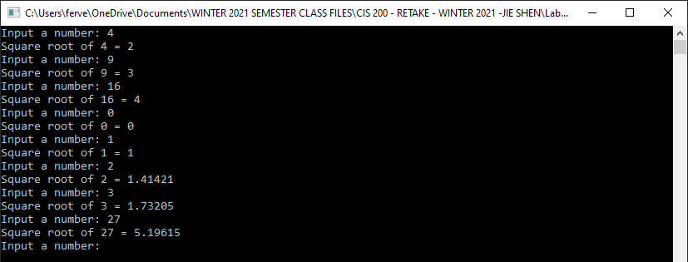
TEST 2:
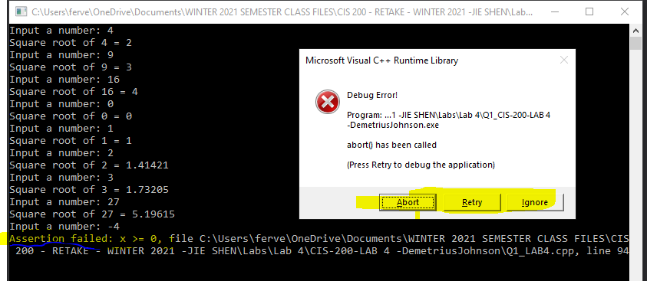

Question 2

Source code (USED C++ COMPILER)
// CIS-200-LAB 4 -DemetriusJohnson.cpp : This file contains the 'main' function. Program execution begins and ends there.
//

/*
//Author: Demetrius E Johnson
//Date: 12 FEB 2021
//Last Modification Date: 2-12-2021
//Purpose: practice using break points

*/

/*
Question 2.

Implement the following main( ):

int main( )
{
int a=1, b=2, c=3;

a++; b--; c++;

cout << a << b << c << endl; // position 1

a++; b--; c++;

cout << a << b << c << endl; // position 2

a++; b--; c++;

cout << a << b << c << endl; // position 3

return 0;
}

When you run this code, what do you see in the DOS window?

Set a regular breakpoint at positions 1, 2, and 3

//Use a stepwise debugging or “continue running” button to show your
//program does stop at each breakpoint and to
//show the values of a, b, and c in the local variables window.
//Create a screenshot at each breakpoint.

*/

#include <iostream>
using namespace std;

int main()
{
int a = 1, b = 2, c = 3;

a++; b--; c++;

cout << a << b << c << endl; // position 1

a++; b--; c++;

cout << a << b << c << endl; // position 2

a++; b--; c++;

cout << a << b << c << endl; // position 3

cout << endl << endl << "The program has finished execution....now exiting...thank you....\n\n";
system("pause");

return 0;
}

Test data and expected results

Test Table:
Test # | Valid / Invalid Data | Description of test | Input Value | Expected Output | Actual Output | Test Pass / Fail
1 | valid | Show start of program | Start debug | NA | See screenshot | pass
2 | valid | Show pause at first BP and var values | Break point | Stop at first break point | See screenshot | pass
3 | valid | Show pause at second BP and var values | Break point | Stop at second break point | See screenshot | pass
4 | valid | Show pause at third BP and var values | Break point | Stop at third break point | See screenshot | pass

TEST 1:
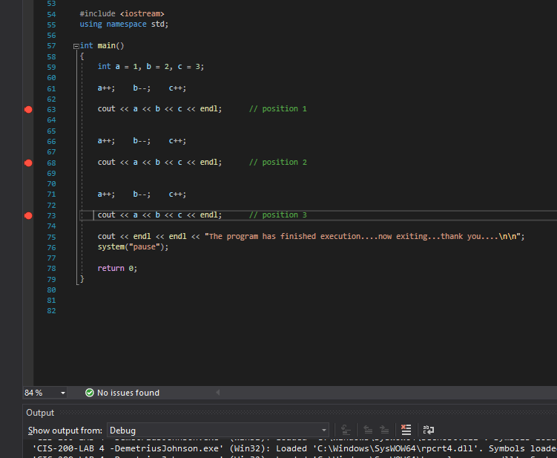
TEST 2:
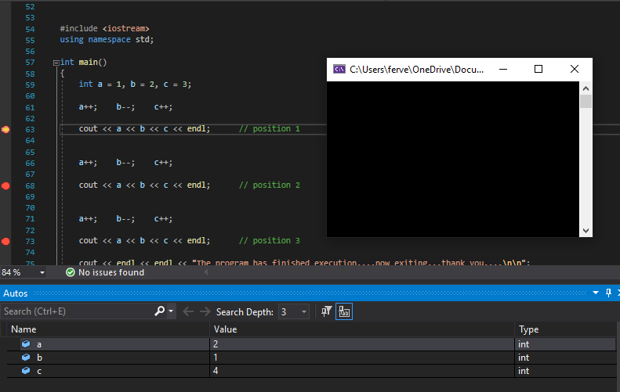
TEST 3:
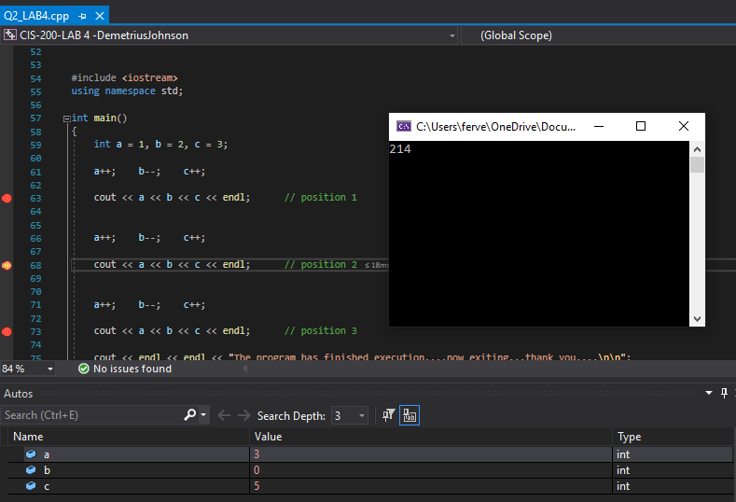
TEST 4:
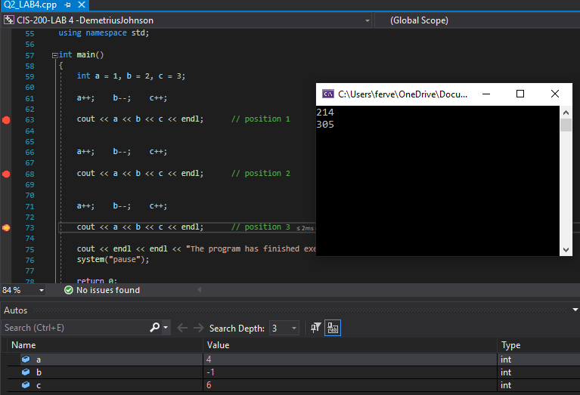

Question 3

Source code (USED C++ COMPILER)
// CIS-200-LAB 4 -DemetriusJohnson.cpp : This file contains the 'main' function. Program execution begins and ends there.
//

/*
//Author: Demetrius E Johnson
//Date: 12 FEB 2021
//Last Modification Date: 2-12-2021
//Purpose: practice using break points

*/

/*
Question 3.

Implement the following factorial( ) and main( ):

Int factorial( int n)
{
If(n == 1)
Return 1;
Else
Return( n* factorial(n-1)); // position 2
}

int main( )
{
int c=3;

cout << “factorial(3)= “ << factorial(c) << endl; // position 1

return 0;
}

(1) Set a regular breakpoint at position 1 and then use step-into button to step into factorial( ).
(2) Inside the factorial( ), use step-over button to move to position 2 and use step-into button to step into the factorial( ) again
(3) Repeat the above step 2 until the recursion finishes the calculation and comes back to the main( )

Make a screenshot at position 1 and each position 2 at different recursive levels.

*/

#include <iostream>
using namespace std;

//FUNCTION DECLARATIONS

int factorial(int n);

//FUNCTION DECLARATIONS

int main()
{
int c = 3;

cout << "factorial(3) = " << factorial(c) << endl; // position 1

cout << endl << endl << "The program has finished execution....now exiting...thank you....\n\n";
system("pause");

return 0;
}

//FUNCTION DEFINITIONS BELOW THIS LINE
int factorial(int n){

if(n == 1)
return 1; //base case
else
return(n * factorial(n - 1)); // position 2 //recursive case
}

Test data and expected results

TEST 1: break point at position 1 encountered at start of program
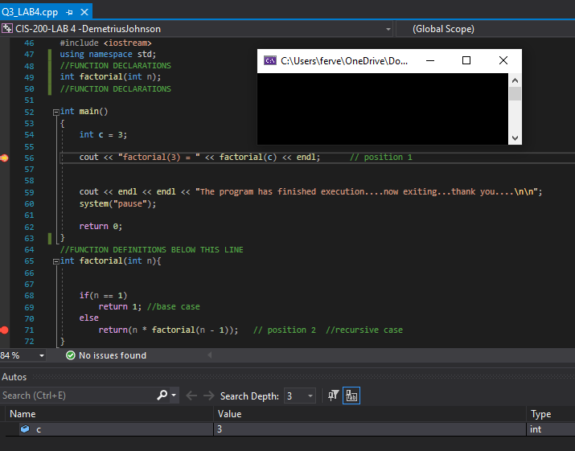
TEST 2: entering the factorial function and stopping at the position 2 break point for first time (level 0 recursive call)
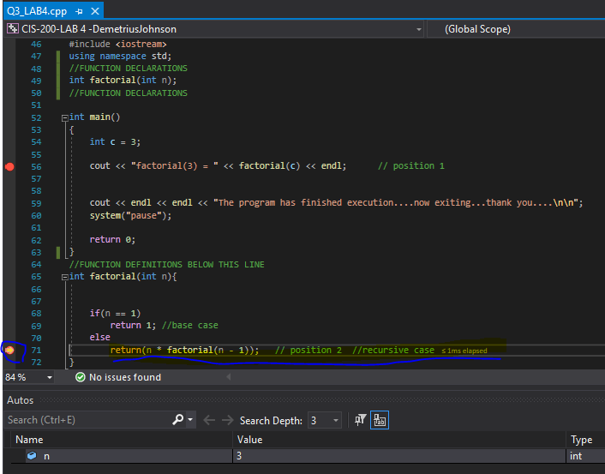
TEST 3: stopping at position 2 again (level 2 recursive call)
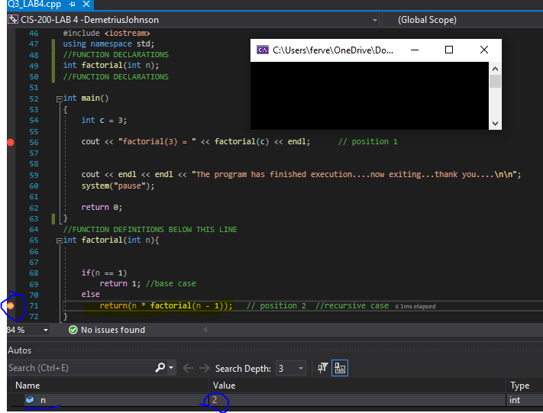
TEST 4: stopping at position 2 for another recursive call to factorial function (level 3)
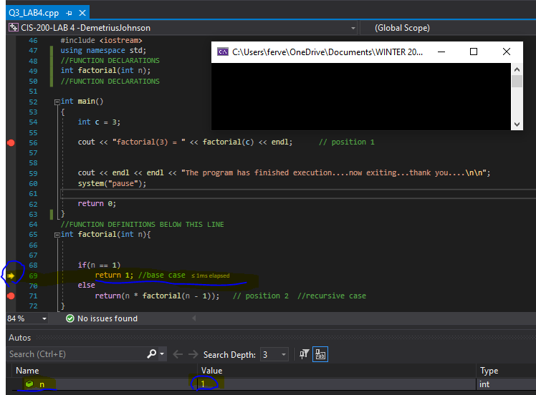
TEST 5: showing the return return back to level 2 recursive call
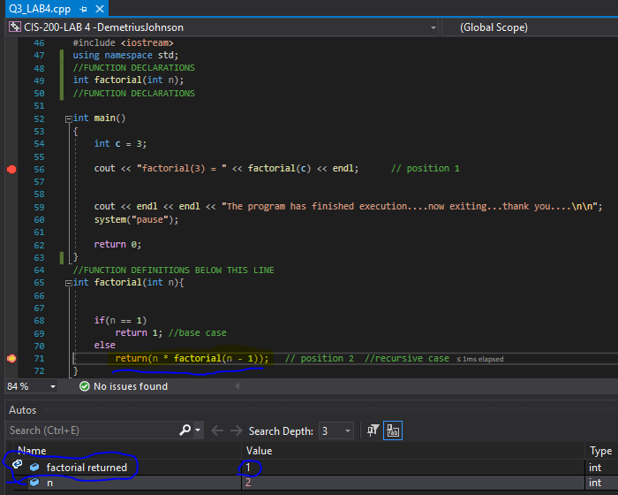

TEST 6: jumping out and going back to MAIN function with the returned value from factorial function call (non-recursive, initial call, level 0; which is the original function call, called by MAIN)
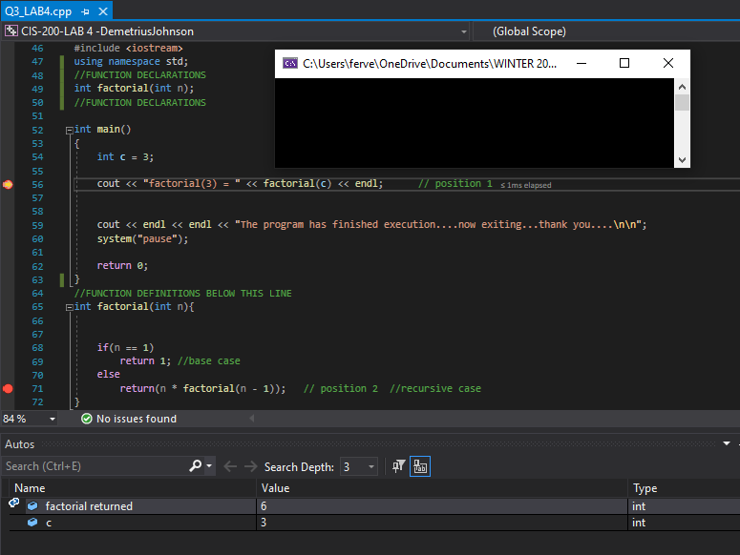
TEST 7: showing the output of the results in the DOS window
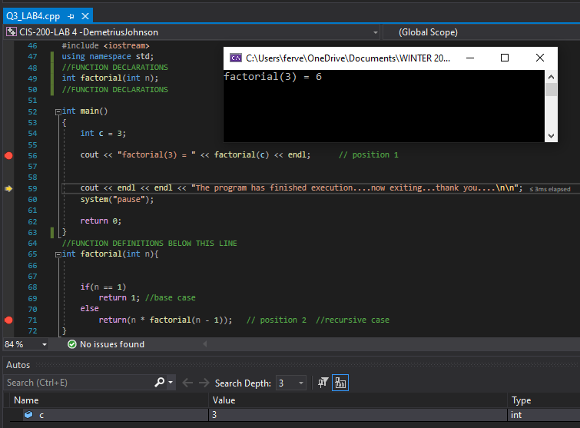

Question 4

Source code (USED C++ COMPILER)
// CIS-200-LAB 4 -DemetriusJohnson.cpp : This file contains the 'main' function. Program execution begins and ends there.
//

/*
//Author: Demetrius E Johnson
//Date: 12 FEB 2021
//Last Modification Date: 2-12-2021
//Purpose: Cryptography program that takes advantage of arrays and char numbers through ASCII standard

*/

/*
Question 4

In cryptography, Caesar cipher is one of the simplest encryption techniques.
The key idea of this method is to replace each plaintext letter with one fixed number of places down the alphabet.
Below is an example with a shift of two:

Plain: ABCDEFGHIJKLMNOPQRSTUVWXYZabcdefghijklmnopqrstuvwxyz
Cipher: CDEFGHIJKLMNOPQRSTUVWXYZabcdefghijklmnopqrstuvwxyzAB

To cipher a string, ‘A’ is replaced by ‘C’, ‘B’ is substituted by ‘D’, and so on. To decode a string, ‘A’ is replaced by ‘y’, etc.

Write a program that takes a char array: “Merry Christmas and Happy New Year.” as an input, encodes the content, and outputs the encoded content to another char array.
Print out the content of the new array on computer screen and make a screenshot.

*/

#include <iostream>
#define STRING_SIZE 35 //size of the sentence to be ciphered (including spaces) //remember: char arrays are not automatically NULL terminated, only string literals
using namespace std;

int main()
{

cout << "----WELCOME to the Simple Cryptography Two-letter Shift program------BY Demetrius Johnson-------\n\n";

cout << "This program will encode the following sentence \"Merry Chistmas and Happy New Year\".\n";
cout << "The cipher algorithm takes every letter from the normal alphabet and shifts it by two letters.\n\n";
cout << "Below is the plain text and the encoded version of that plain text (the cipher):\n\n";
cout << " Plain Text: ABCDEFGHIJKLMNOPQRSTUVWXYZabcdefghijklmnopqrstuvwxyz\n";
cout << " Ciphered text: CDEFGHIJKLMNOPQRSTUVWXYZabcdefghijklmnopqrstuvwxyzAB\n\n";
cout << "For example: 'A' is replaced by 'C' ('A' is shifted over/down the alphabet two characters --> 'C').\n\n\n";
cout << "Inputting:\t 'Merry Christmas and Happy New Year'\n\nYields the output: '";

char original[STRING_SIZE] = "Merry Christmas and Happy New Year"; //remember: char arrays are not automatically NULL terminated, only string literals;
//so to initialize this array using a string literal I needed to do size + 1 since the last char will be the NULLCHAR character.
char ciphered[STRING_SIZE]; //this is where the ciphered string will be stored

int shift_TWO = 2; //shifts the value forward (letter) by a value of 2
int shift_TO_LOWER = 6; //shift forward to upper case letters
int shift_TO_UPPER = -58; //go from end of lower case letters (beginning at 'y') back to upper case letters

//NOTE ASCII TABLE: letters A-Z == Decimal 65-90; a-z == Decimal 97-122 (separation of 7 units between 'Z' and 'a')
for (int count = 0; count < STRING_SIZE; count++) { //remember string size includes the NULL CHAR at the last element

if (original[count] == 32) { //32 == ' ' (empty space char)

ciphered[count] = 32;
cout << ciphered[count];

}
else if (original[count] > 64 && original[count] < 89) { //65 - 88 == A - X //for Y and Z we need to account for jumping to 'a' and 'b' which begin at 97

ciphered[count] = (original[count] + shift_TWO);
cout << ciphered[count];
}
else if (original[count] == 89 || original[count] == 90) { //handle case where shift forward two jumps from upper case to lower case letters

ciphered[count] = (original[count]) + (shift_TWO + shift_TO_LOWER); //plus 6 (shift to lower) to jump to lower case letter range which begin at 97
cout << ciphered[count];
}
else if (original[count] > 96 && original[count] < 121) { //97 - 120 == a - x //for 'y' and 'z' we need to handle the wrap-around case and jump back to Upper cased letters

ciphered[count] = (original[count] + shift_TWO);
cout << ciphered[count];
}
else if (original[count] == 121 || original[count] == 122) { //handle case where shift forward requires jumping back to the start of upper case letters

ciphered[count] = (original[count]) + shift_TO_UPPER + shift_TWO; //shift (backwards) to upper case letters by subtracting 58; then shift by 2.
cout << ciphered[count];
}
}

cout << "'";

cout << endl << endl << "\n\n\nThe program has finished execution....now exiting...thank you....\n\n";
system("pause");

return 0;
}

Test data and expected results

Test Table:
Test # | Valid / Invalid Data | Description of test | Input Value | Expected Output | Actual Output | Test Pass / Fail
1 | valid | Show the output of the ciphered text | “Merry Christmas and Happy New Year | “OgttA Ejtkuvocu cpf JcrrA Pgy agct” | See screenshot | pass

TEST 1:
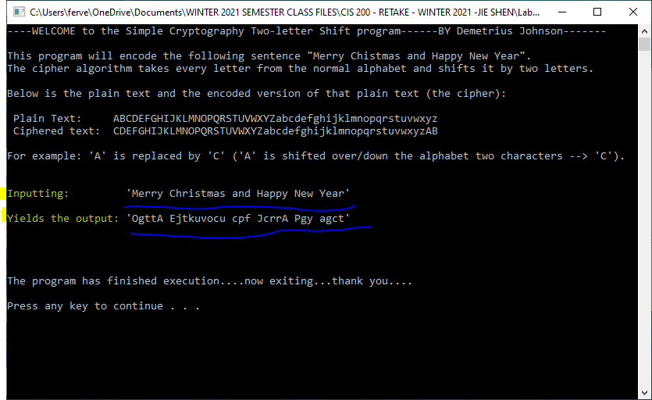

Submission

Provide the following in an MS word document:
- Cover page with lab number and title, your name, date
- Source code (identify which compiler you used)
- You should submit your work through Canvas site for cis 200 lab.
- The filename of the word document should follow the convention: FirstName_LastName_Cis200Lab3.doc.

